EXP NO 3:
Aim
Detect image edges using Canny edge detection algorithm.
Algorithm
- Import OpenCV and Matplotlib required Python libraries.
- Read input image from specified file location.
- Convert color image into grayscale using OpenCV.
- Apply Canny edge detection with threshold values.
- Display detected edges using Matplotlib grayscale color map.
- Verify detected edges from processed output image.
Code
import cv2
import matplotlib.pyplot as plt

img = cv2.imread("/content/Picture1.jpg")
gray = cv2.cvtColor(img, cv2.COLOR_BGR2GRAY)

edges = cv2.Canny(gray, 100, 200)

plt.imshow(edges, cmap="gray")
plt.show()
Output:
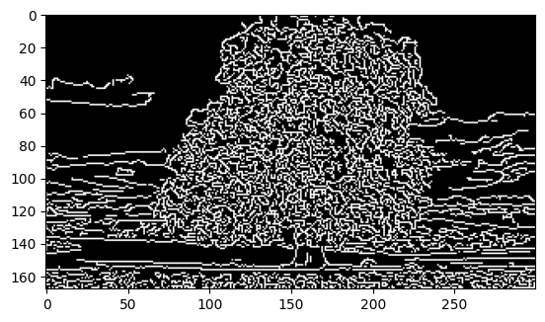
Result
The input image was successfully processed using the Canny edge detection algorithm, and the detected edges were displayed successfully.

